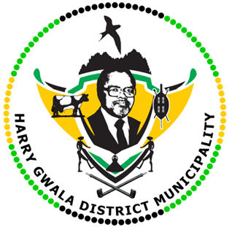
HARRY GWALA DISTRICT MUNICIPALITY
“Together We Deliver and Grow”
OFFICE OF THE MUNICIPAL MANAGER
40 Main Street, Private Bag X501, IXOPO 3276
Tel: (039) 834 8707 Fax: (039) 834 1701
Email: kunenes@harrygwaladm.gov.za
EXTERNAL ADVERTISEMENTS

INFRASTRUCTURE SERVICES DEPARTMENT
POST: EXPANDED PUBLIC WORKS PROGRAMME: DISASTER MANAGEMENT [10]

SALARY: R 2 400 PER MONTH
DURATION: 12 MONTHS CONTRACT
JOB REQUIREMENTS
- Must be unemployed.
- Matric /Grade 12
- Strictly reside within the Harry Gwala District Municipality and Specific ward
- Must not have been on the EPWP programme at Harry Gwala District Municipality for longer than 3 years.
- Persons with disabilities are encouraged to apply.
- The following demographic targets will be considered during the selection of Participants.
- 60% Women
- 55% youth
- 2% Persons living with disabilities.
KEY PERFORMANCE AREAS
- Ability to respond to the incident and disaster.
- Providing additional response capacity through several roles.
- Conduct risk assessments
- Conduct disaster management awareness campaign to communities.
- Assist in all disaster related activities and challenges the community

Participants will be places at the following Municipal premises of the Harry Gwala District Municipality:
WARD | UMZIMKHULU SATELLITE | NUMBER OF PARTICIPANTS
10 |  | 1
12 |  | 1
14 |  | 1
17 |  | 1
18 |  | 1
21 |  | 1

WARD | UBUHLEBEZWE SATELLITE | NUMBER OF PARTICIPANTS
4 | Disaster Centre | 1
6 |  | 1
8 |  | 1
12 |  | 1

APPLICATIONS WITHOUT THE FOLLOWING DOCUMENTS WILL NOT BE CONSIDERED

- Curriculum vitae
- Copy of certified South African Identity document and any other qualification you may have
- Proof of residence for the specific ward you are applying for
- Recommendation letter from the Ward Councilor confirming the indigency.

Enquires should be directed to the Municipal Works Unit on 039-834 8704/8742/8731/. No faxed or emailed applications will be accepted.
Applications must be submitted to the Municipal Manager for Attention: Mr N.E Biyase, Executive Director: Infrastructure Services, Harry Gwala District Municipality, Private Bag X 501, IXOPO, 3276, or can be hand delivered at 40 Main Street, IXOPO, 3276, to reach us no later than 15H00, 19 June 2023.
Further correspondence will be confined to shortlisted candidates. If you have not been contacted within four months of the closing date of the advertisement, please accept that your application has been unsuccessful.
NB: Canvassing with Councillors or Management will lead to immediate disqualification. Harry Gwala District Municipality subscribes to the National Equity Strategy.
The Council reserves the right not to continue with the appointment if it feels that no suitable candidates identified.

MR G.M SINEKE
MUNICIPAL MANAGER

